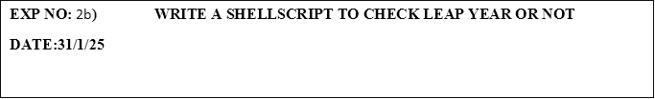

**PROGRAM:**

#!/bin/bash

# Prompt the user to enter a year

echo "Enter a year:"

read year

# Check if the year is divisible by 4

if (( year % 4 == 0 )); then

    # If it is divisible by 100, it should also be divisible by 400 to be a leap year

    if (( year % 100 == 0 )); then

        if (( year % 400 == 0 )); then

            echo "$year is a leap year"

        else

            echo "$year is not a leap year"

        fi

    else

        echo "$year is a leap year"

    fi

else

    echo "$year is not a leap year"

fi

**OUTPUT:**

Enter a year:

2004

2004 is a leap year